**22” Outdoor End Table Assembly Instructions**

Hardware Included

* 4- 20 x ¼” x 4” carriage bolts
* 4- ¼” flat washers
* 4- 20 x ¼” nuts
* 4- decorative bolt caps
* 8- #8 x 1 ¾” T20 screws

Tools Needed for Assembly

* 7/16” Wrench, 7/16” Socket and rachet, or Adjustable wrench
* T20 screwdriver (included in hardware bag)
* Scissors or cutting tool, to remove packaging

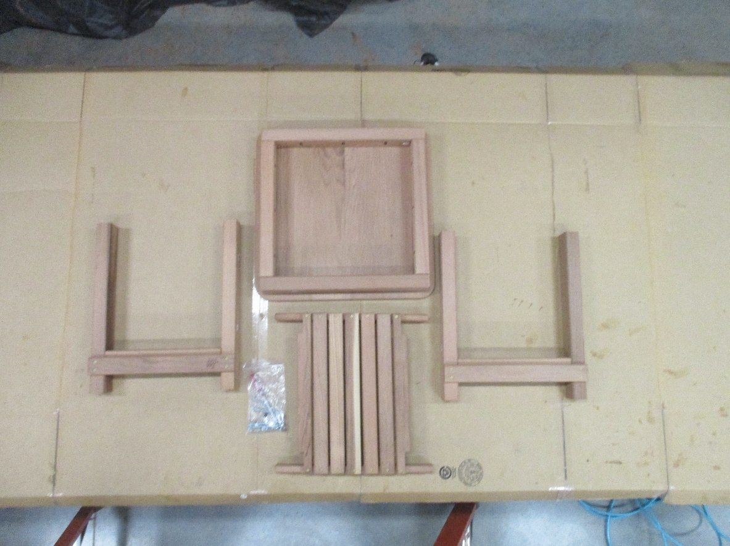Assembly Instructions

1. Unpackage all the parts and layout on a clean work area

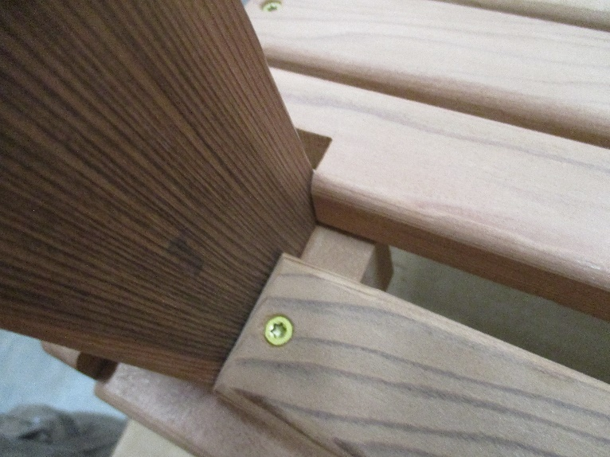

2. Locate the 2 leg and shelf assemblies. Match up A1 on the right leg assembly with A1 on the shelf. The notched shelf runner will rest on the support attached to the leg assembly. The shelf frame and leg frame pieces should be flush with each other. The parts may be a tighter fit. Hand tighten down 2, 1 ¾” screw into the holes. As you screw the parts may move a little. That is the screw finding the hole. Once the screws are hand tight and located in the holes, screw them down with the screwdriver. Repeat for the other side of the leg assembly with A2. Then with the other leg assembly with A3 and A4.

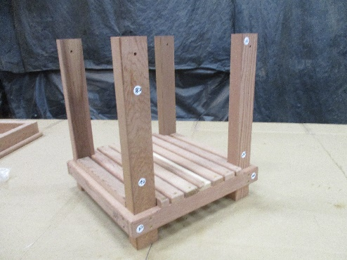

3. Flip the top upside down. With the legs assembled to the shelf, orient the legs so B1-B4 line up with the corresponding B1-B4 on the top. Once all the numbers line up, slide the legs into the frame on the top. You may have to flex the legs in slightly.

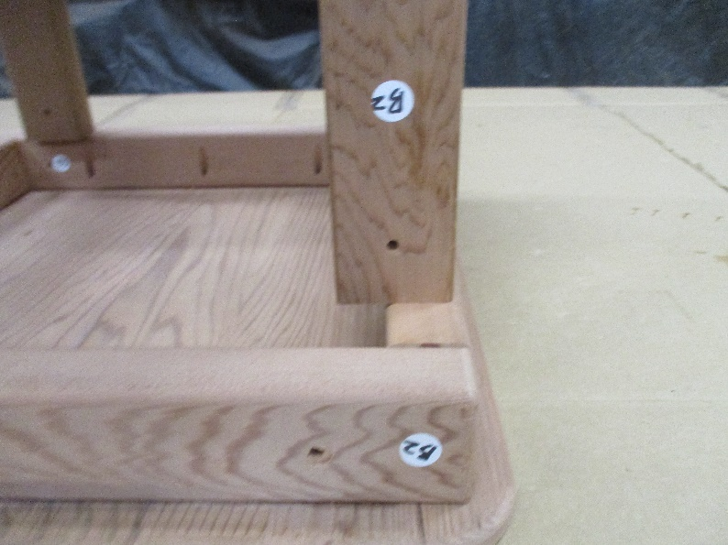

4. Once the legs are resting on the top, slide in the 4 carriage bolts into each hole on the top frame into the legs. The hole next to A1-A4 Put a nut and washer onto each bolt and tighten them down with a 7/16” wrench, 7/16” socket and rachet or an adjustable wrench. Once all the bolts are tight put a decorative bolt cap on the end of each carriage bolt.

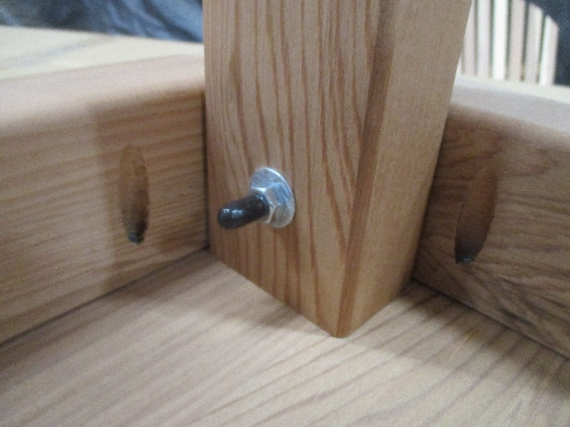

5. Remove the sticker labels and enjoy your now assembled quality Redwood 22” Outdoor End Table. (If you want to apply a desired finish, once the labels are removed you can do that. To make sure the product is 100% fully coated we recommend you disassemble the product and let every part fully dry before reassembling, but you will have to reassemble it without the labels)

